# Media Analysis - Will ChatGPT and AI have an impact on Saudi workforce productivity

## Short Summary

The article explores how ChatGPT and AI technologies are reshaping Saudi workforce productivity via tailored training, online courses, collaboration enhancement, upskilling, reskilling, and knowledge management, yet acknowledges potential job displacement due to automation and underscores the necessity for strategic implementation considering operational challenges.

## Summary

1. **AI technologies like ChatGPT are revolutionizing global workforces, providing an opportunity to boost productivity in Saudi Arabia.**  
2. **ChatGPT's popularity has alleviated fears among employees about job replacement by AI, emphasizing the potential for collaboration between humans and machines.**  
3. **AI can significantly impact career-related skills through tailored training programs, access to online courses, and fostering team collaboration.**  
4. **In the public sector, healthcare, transportation, energy, finance, and retail sectors, AI will restructure operations, enhancing efficiency and service delivery.**  
5. **While ChatGPT is likely to replace workers performing mundane tasks, it also creates opportunities for upskilling and reskilling to adapt to an increasingly AI-driven world.**  
6. **The implementation of AI in Saudi companies necessitates a holistic approach that defines strategic objectives, identifies operational bottlenecks, and chooses optimal tools or technologies.**  
7. **To successfully integrate AI, organizations need solid leadership, foresight, agility, and an optimistic environment for learning to accommodate employees and clients during the transition.*

## Question 1:

How do the media in this article frame the public discussion about ChatGPT? Are there certain **metaphors** that keep cropping up?

The media frames ChatGPT as a transformative force that is shaping the future of the Saudi workforce. Metaphors like 'wave of change', 'useful tool for boosting productivity', 'embracing innovation to boost productivity', and 'AI's paradoxical nature alongside positive impact on recruitment' keep recurring, emphasizing ChatGPT as a tool that both challenges traditional employment roles and augments capabilities.

## Question 2:

Which role does or might the Arabic World play in the development of Artificial Intelligence? Answer with 'Not mentioned' if not applicable.

Not mentioned

## Question 3:

Which use cases of Artificial Intelligence are helpful for the Arabic world based on this article?

These use cases of Artificial Intelligence are helpful for the Arabic world as they aim to boost productivity, efficiency, and strategic decision-making within various sectors such as healthcare, transportation, energy, finance, and retail.

## Question 4:

What is the final message of the article that the author wants to convey? Keep your answer short and precise!

Strategic integration of AI technologies like ChatGPT in workforces can lead to increased productivity and improved services across sectors such as healthcare, transportation, energy, finance, and retail. However, this transition requires employees to upgrade skills due to potential job displacement from automation. Solid leadership, a future-oriented mindset, and continuous learning are essential for successful AI implementation.

## Sentiment

The sentiment is 4

## Entities

Khoury, Embed Ai Operation Saudi Company Employee Require Holistic Approach, Task Automate, Foster Collaboration Communication Team, Regard Energy Sector Innovative Technology, Chatgpt Ai Impact Saudi Workforce, Raymond Khoury, Arthur

## Topic Clusters

### Cluster: Artificial Intelligence (AI) Technologies

ChatGPT, AI applications, machine learning

### Cluster: Ethical and Societal Implications

societal effects of AI, ChatGPT's impact on society, regulations for AI

### Cluster: Job Market Disruption

how ChatGPT affects jobs, job displacement due to AI

## Word Clouds

### Wordcloud of content

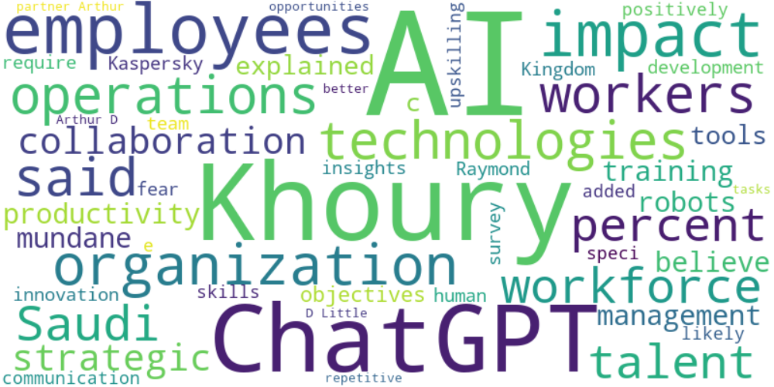

Top 10 words:

- AI: 34

- Khoury: 16

- ChatGPT: 12

- employees: 11

- impact: 9

- technologies: 6

- operations: 6

- said: 6

- workers: 6

- Saudi: 5

### Wordcloud of summary

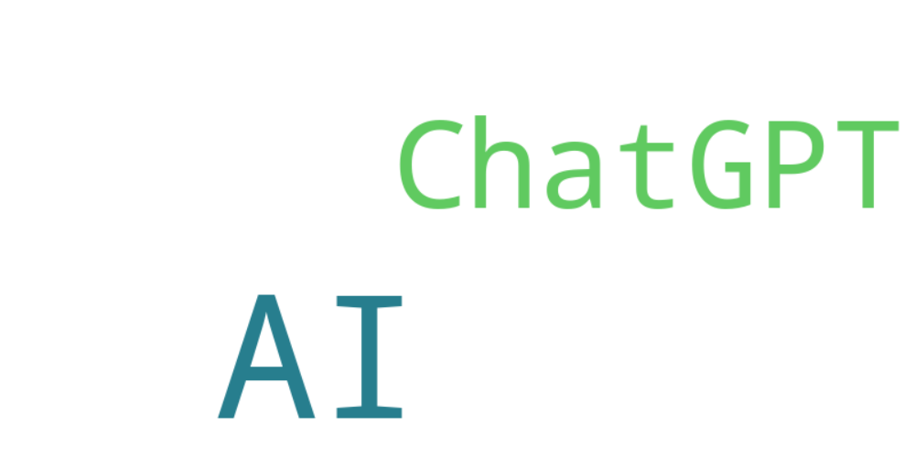

Top 10 words:

- AI: 7

- ChatGPT: 3